ACCUMULAtoR

E-AGLE Trento Racing Team

Università degli studi di Trento

Via Fortunato Zeni 8, Rovereto, Italy

Energus module 6p

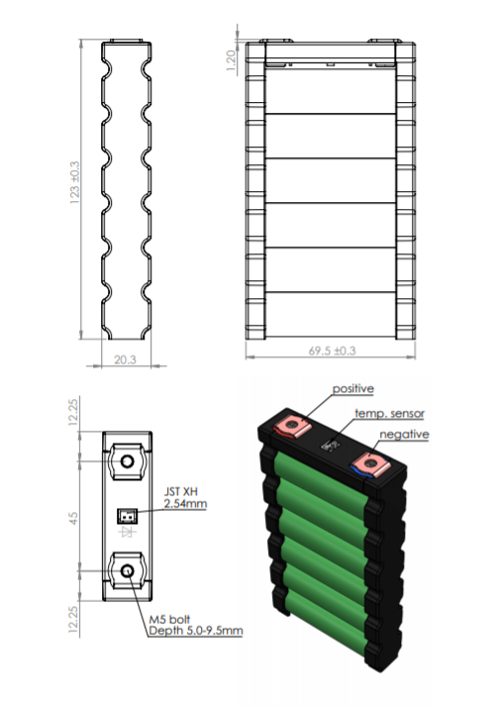

Brusa charger for the accumulator

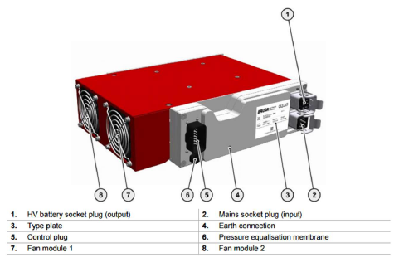

Orion BMS solution (2016/2017) schematic

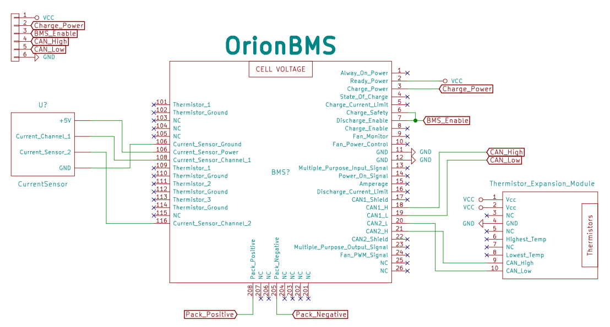

Powertrain render: two Bamocar Inverters, battery pack, cooling collector, two Emrax DC motor

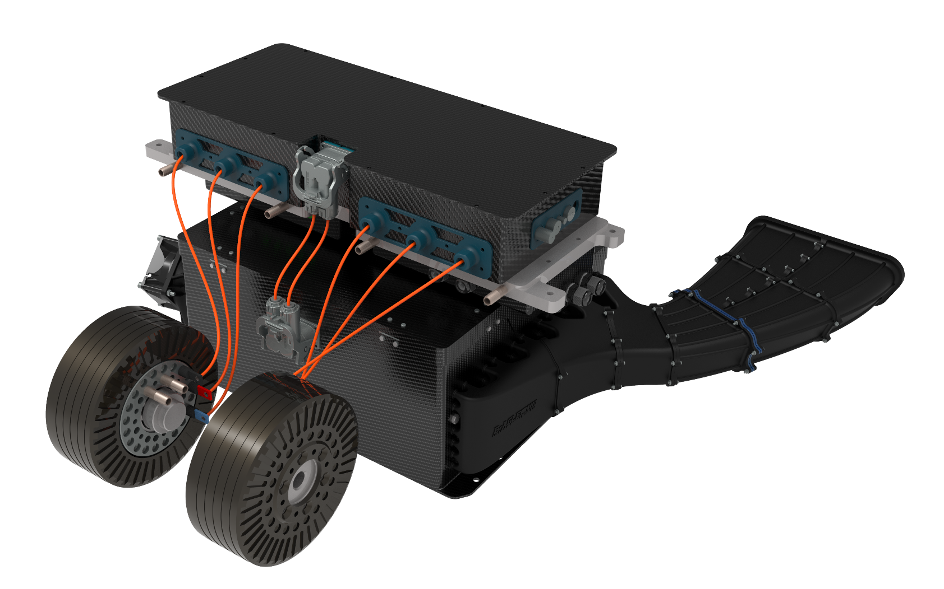

Internal view of battery pack

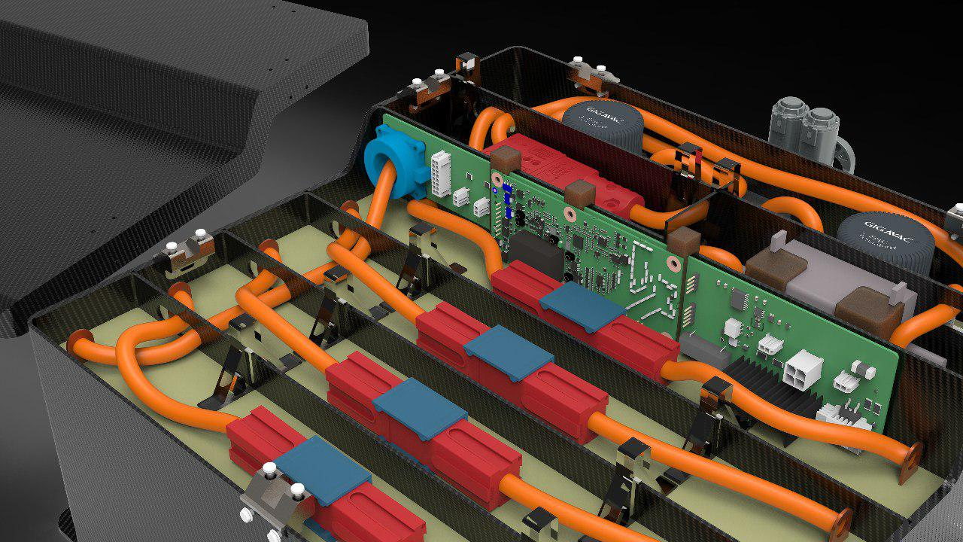

Mainboard

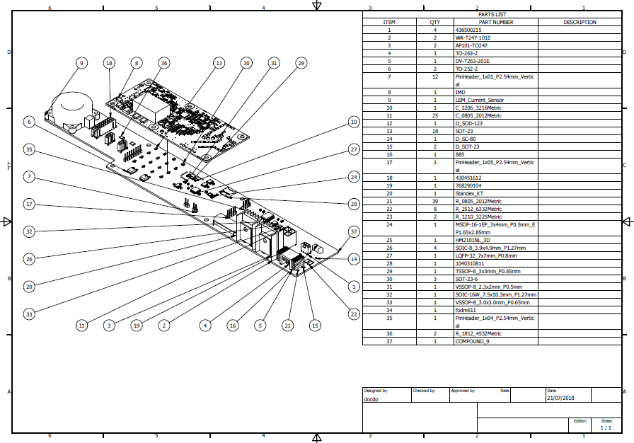

Cell board

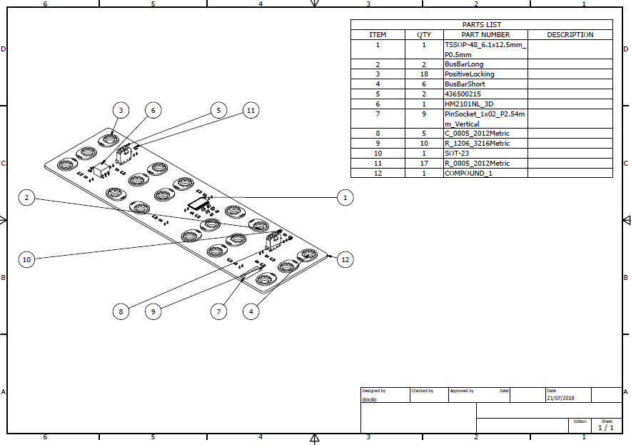

LTC main integrated of the cellboard

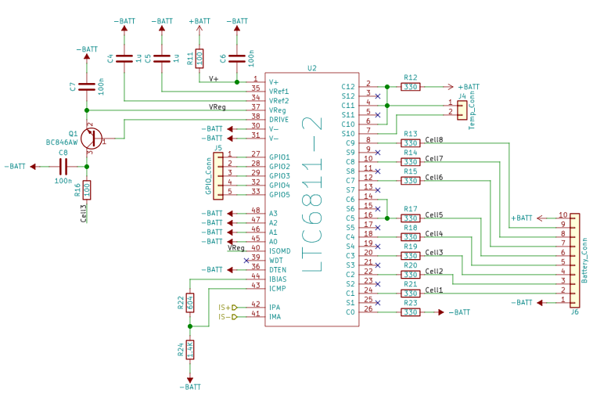

Exploded of the HV content

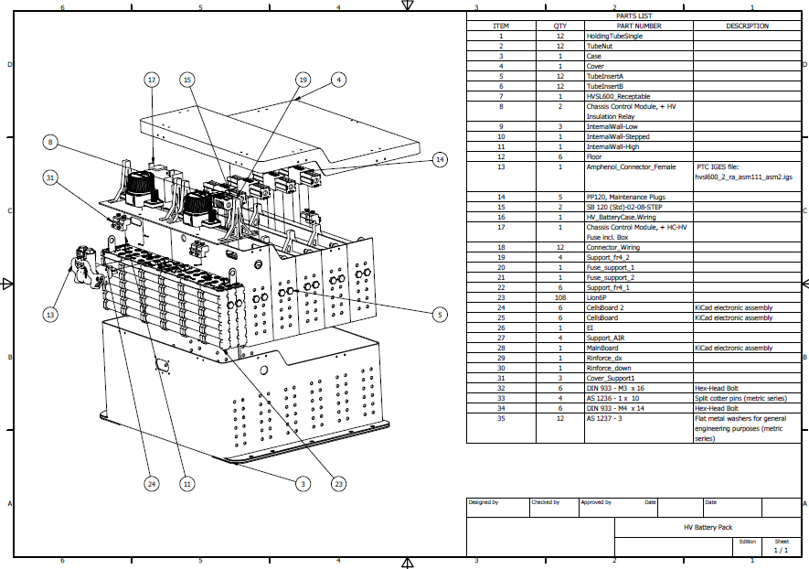

Exploded of HV case

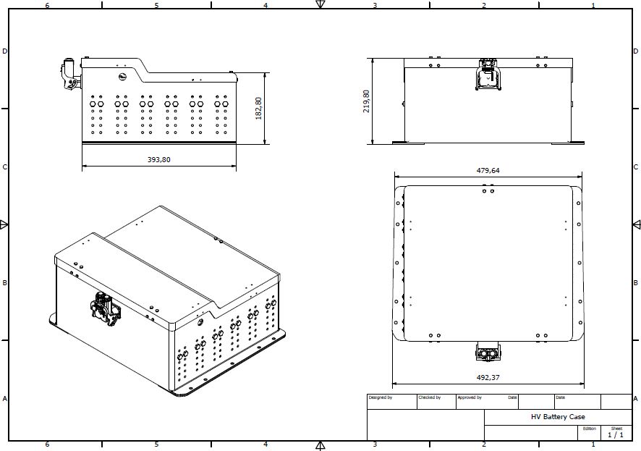

BMS basic schematic

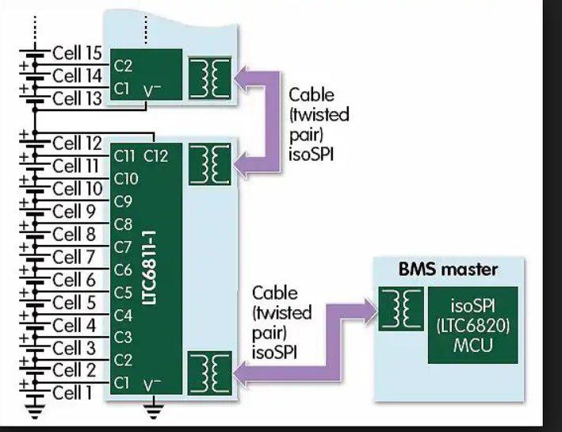

**HV BATTERY PACK DESING**

Project planning

Our first year battery pack was designed

We chose Energus Energy Solution as supplier for battery modules, each module is composed by six Sony VTC5 battery in parallel.The configuration of battery pack was 120s6p for a total pack voltage of 504 V and 6,7 Wh.

The battery case was realized in steel.

The accumulator weighted 80kg.

The design process of the new battery pack was born consequently of deep analysis of the performances of the first year battery pack related to the endurance session.

By reducing the number of series to 108 ( 456 V 5,6 Wh), the use carbon fiber material to realize the HV case and the development of a new BMS allow to achieve better performances, thanks to the weight reduction (46kg).

Battery monitoring sistema design

* 1. project planning

In our first year HV battery pack we adopdet the Orion battery management system solution.The BMS had a centralized architecture based on Linear chipsets.It provided us the information about temperature and voltage of each modulels including under/over voltage/current/temperature detection.The case was composed by steel, on the top of the case are placed a big dissipator.The utility software, also provided by Orion, allow to tweak some parameters.

The desgn process was born by the idea of realizing a custom battery management system designed in synergy with our accumulators solution.This new design is characterized by an hybrid architecture that allows us to achieve a consistent weight and dimensional reduction.The hybrid architecture allows us to overcome the limitations in data transfer and communication of the Orion BMS.

Architecture

There is a Main board that communicates through and isolated SPI protocol to other 12 Cell boards that retrieve information about voltage and temperature of each modules.The MCU of the main board is STM32f348K8 and has the aim of sampling the data of the cell boards, the data of the current sensor and it manages the shutdown circuit.

Shutdown circuit

Wherever the power train is powered on, the MCU loops until the voltage of the Battery pack is equivalent to the voltage of the inverter exploiting the precharge circuit.As soon it occurs, the Air closed the circuit and the current can flow through inverters.

An additional security check is performed whenever the vehicle goes in RUN mode. Each 10 ms cell data are sampled and an evaluation is done in order to check under/over voltage/temperature/current.

Whenever any of these case occurs the shutdown circuit open the AIRs, interrupting HV current erogation, preventing any possible damage.

Grazie